**I. Pen-and-paper**

1. A math equations on a grid

   Description automatically generated

1. Answer 4

**II. Programming and critical analysis**

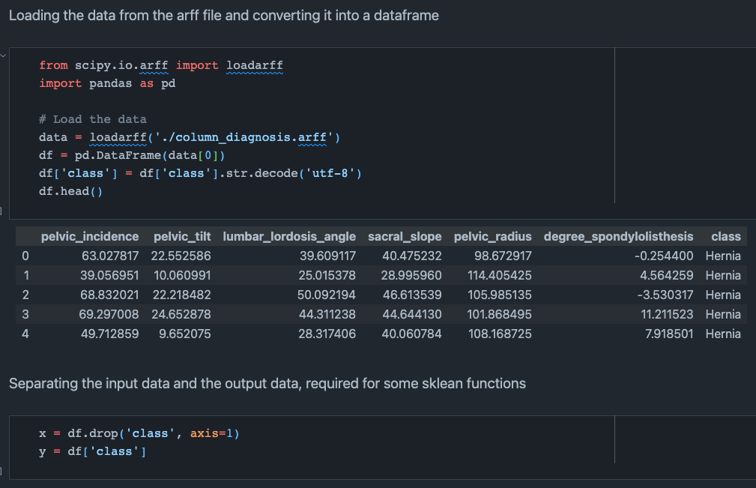

In the results from Question 2, we can observe the relationship between the max depth of the decision tree and its training and testing accuracies. We can see some key points from the plot:

- As the max depth of the decision tree increases, the training accuracy generally improves. This is expected because a deeper tree can fit the training data better, and hence, the training accuracy will improve.

- When analyzing the testing accuracy, it shows a different trend. Initially, as the tree uses a smaller depth limits, the testing accuracy improves. But, after a certain point (around depth of 5), the testing accuracy starts to decline. This is a clear sign of overfitting. The model is overfitting the training data and hence, the testing accuracy is declining.

- Considering the prior analysis, the optimal max depth for the decision tree is 5. Beyond that point, the model tens to overfit the training data and hence, the testing accuracy starts to decline.

1. i)  
   A screen shot of a computer code

   Description automatically generatedA diagram of a tree

   Description automatically generated

ii)

The conditions to indentify an hernia are, according to the decision tree are:

- a degree_spondylolisthesis value less than 16.079 and a sacral_slope value less than 28.136.

- a degree_spondylolisthesis value less than 16.079 and a pelvic_radius value less than 117.36 and a sacral_slope value less than 40.149.

**END**